**Week 2.3:**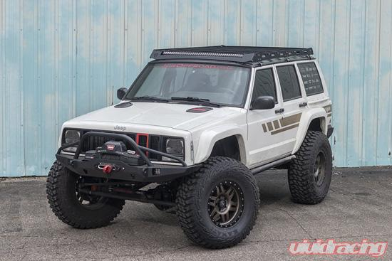

Continue to use the system you chose and further analyze the nameplate data or technical specifications for it. It may be necessary to use both nameplate data and technical specifications if your system has both. Include a picture of your system and its technical specifications or nameplate in your document. Create a word document that presents this information and then answers the following questions:

* What type of voltage and phase does your system run/require?

**My Jeep runs AC Voltage at 3-phase, but goes directly into two diodes per coil to direct the flow of current (DC voltage). Then goes through a regulator to insure proper power for the battery and other components.**

* Does your system have an option to run on a different voltage level or phase?

**No, most automobile engines use 3-phase AC alternators with a usage output of 12-14v.**

* Are there similar models of your system that would require a different voltage or phase?

**No, although in the few models that have Diesel engines they use a WYE setup instead of a delta because of the RPM difference between Gas and Diesel engines.**